CIA-2

1)

CODE:

**package** CIA_1;

**import** org.openqa.selenium.By;

**import** org.openqa.selenium.WebDriver;

**import** org.openqa.selenium.WebElement;

**import** org.openqa.selenium.chrome.ChromeDriver;

**import** org.openqa.selenium.chrome.ChromeOptions;

**import** org.openqa.selenium.firefox.FirefoxDriver;

**import** io.github.bonigarcia.wdm.WebDriverManager;

**public** **class** CIA1_1 {

**public** **static** **void** main(String[] args) **throws** InterruptedException {

ChromeOptions co = **new** ChromeOptions();

co.addArguments("--remote-allow-origins=*");

WebDriverManager.*chromedriver*().setup();

WebDriver drive=**new** ChromeDriver();

drive.get("https://www.amazon.in");

drive.manage().window().maximize();

Thread.*sleep*(3000);

drive.findElement(By.*xpath*("/html/body/div[1]/header/div/div[1]/div[3]/div/a[2]/div")).click();

Thread.*sleep*(3000);

drive.findElement(By.*xpath*("//*[@id=\"ap_email\"]")).sendKeys("9840632672");

Thread.*sleep*(3000);

drive.findElement(By.*xpath*("//*[@id=\"continue\"]")).click();

Thread.*sleep*(3000);

drive.findElement(By.*xpath*("//*[@id=\"ap_password\"]")).sendKeys("Skcet@123");

Thread.*sleep*(3000);

drive.findElement(By.*xpath*("//*[@id=\"signInSubmit\"]")).click();

Thread.*sleep*(3000);

drive.findElement(By.*xpath*("//*[@id=\"twotabsearchtextbox\"]")).sendKeys("cube");

Thread.*sleep*(3000);

drive.findElement(By.*xpath*("//*[@id=\"nav-search-submit-button\"]")).click();

Thread.*sleep*(3000);

drive.navigate().to("https://www.amazon.in/Storio-Sticker-Brainstorming-Adjustable-Tightness/dp/B085DZM4JS/ref=sr_1_5?crid=2GFID88KY92VZ&keywords=cube&qid=1683195529&sprefix=cube%2Caps%2C723&sr=8-5&th=1");

Thread.*sleep*(3000);

drive.findElement(By.*xpath*("//*[@id=\"add-to-cart-button\"]")).click();

Thread.*sleep*(3000);

WebElement cart=drive.findElement(By.*xpath*("//*[@id=\"sc-subtotal-label-activecart\"]"));

String add=cart.getText();

String Exp="Subtotal(1 item):";

**if**(cart.equals(Exp)) {

System.***out***.println("Item added");

}

**else** {

System.***out***.println("No item");

}

Thread.*sleep*(2000);

drive.findElement(By.*xpath*("/html/body/div[1]/div[2]/div[3]/div[5]/div/div[2]/div[1]/div/form/div[2]/div[3]/div[4]/div/div[3]/div[1]/span[1]/span/span[1]/span/span/span/span")).click();

Thread.*sleep*(2000);

drive.findElement(By.*xpath*("//*[@id=\"quantity_3\"]")).click();

Thread.*sleep*(3000);

WebElement cart1=drive.findElement(By.*xpath*("//*[@id=\"sc-subtotal-label-activecart\"]"));

String upd=cart1.getText();

String Expupd="Subtotal(3 items):";

**if**(upd.equals(Expupd)) {

System.***out***.println("Updated");

}

**else** {

System.***out***.println("Done");

}

Thread.*sleep*(3000);

drive.findElement(By.*xpath*("/html/body/div[1]/div[2]/div[3]/div[5]/div/div[2]/div[1]/div/form/div[2]/div[1]/div[4]/div/div[3]/div[1]/span[2]/span/input")).click();

Thread.*sleep*(3000);

WebElement rcart=drive.findElement(By.*xpath*("/html/body/div[1]/div[2]/div[3]/div[5]/div/div[2]/div[1]/div/div[1]/div/h1"));

String rem=rcart.getText();

String remove="Your Amazon Cart is empty.";

**if**(rem.equals(remove)) {

System.***out***.println("Product Removed");

}

**else** {

System.***out***.println("Thank You");

}

Thread.*sleep*(3000);

drive.findElement(By.*xpath*("//*[@id=\"twotabsearchtextbox\"]")).sendKeys("cube");

Thread.*sleep*(3000);

drive.findElement(By.*xpath*("//*[@id=\"nav-search-submit-button\"]")).click();

Thread.*sleep*(3000);

drive.findElement(By.*xpath*("/html/body/div[1]/div[2]/div[1]/div[1]/div/span[1]/div[1]/div[7]/div/div/div/div/div[3]/div[1]/h2")).click();

Thread.*sleep*(3000);

drive.findElement(By.*xpath*("//*[@id=\"add-to-cart-button\"]")).click();

Thread.*sleep*(3000);

drive.findElement(By.*xpath*("/html/body/div[1]/div[2]/div[3]/div[5]/div/div[1]/div[1]/div/form/div/div/span/span/span/input")).click();

Thread.*sleep*(3000);

WebElement cho=drive.findElement(By.*xpath*("/html/body/div[5]/div[1]/div/div[1]/div/div[3]/h1"));

String chout=cho.getText();

String expcho="Checkout";

**if**(chout.equals(expcho)) {

System.***out***.println("Checkedout");

}

**else** {

System.***out***.println("Still There");

}

Thread.*sleep*(3000);

drive.findElement(By.*xpath*("/html/body/div[5]/div[1]/div/div[2]/div/div/div[1]/div[1]/div/div[1]/div/div[3]/div/div[2]/div/div[2]/form/div/div[2]/div/span/span/input")).click();

Thread.*sleep*(3000);

WebElement tot=drive.findElement(By.*xpath*("/html/body/div[5]/div[1]/div/div[2]/div/div/div[2]/div/div[1]/div/div[2]/div/div[1]/div/div[2]/table/tbody/tr[4]/td[2]"));

String otot=tot.getText();

String exptot="₹95.00";

**if**(otot.equals(exptot)) {

System.***out***.println("Order Total"+exptot);

}

**else** {

System.***out***.println("Bye");

}

Thread.*sleep*(3000);

drive.close();

}

}

OUTPUT:

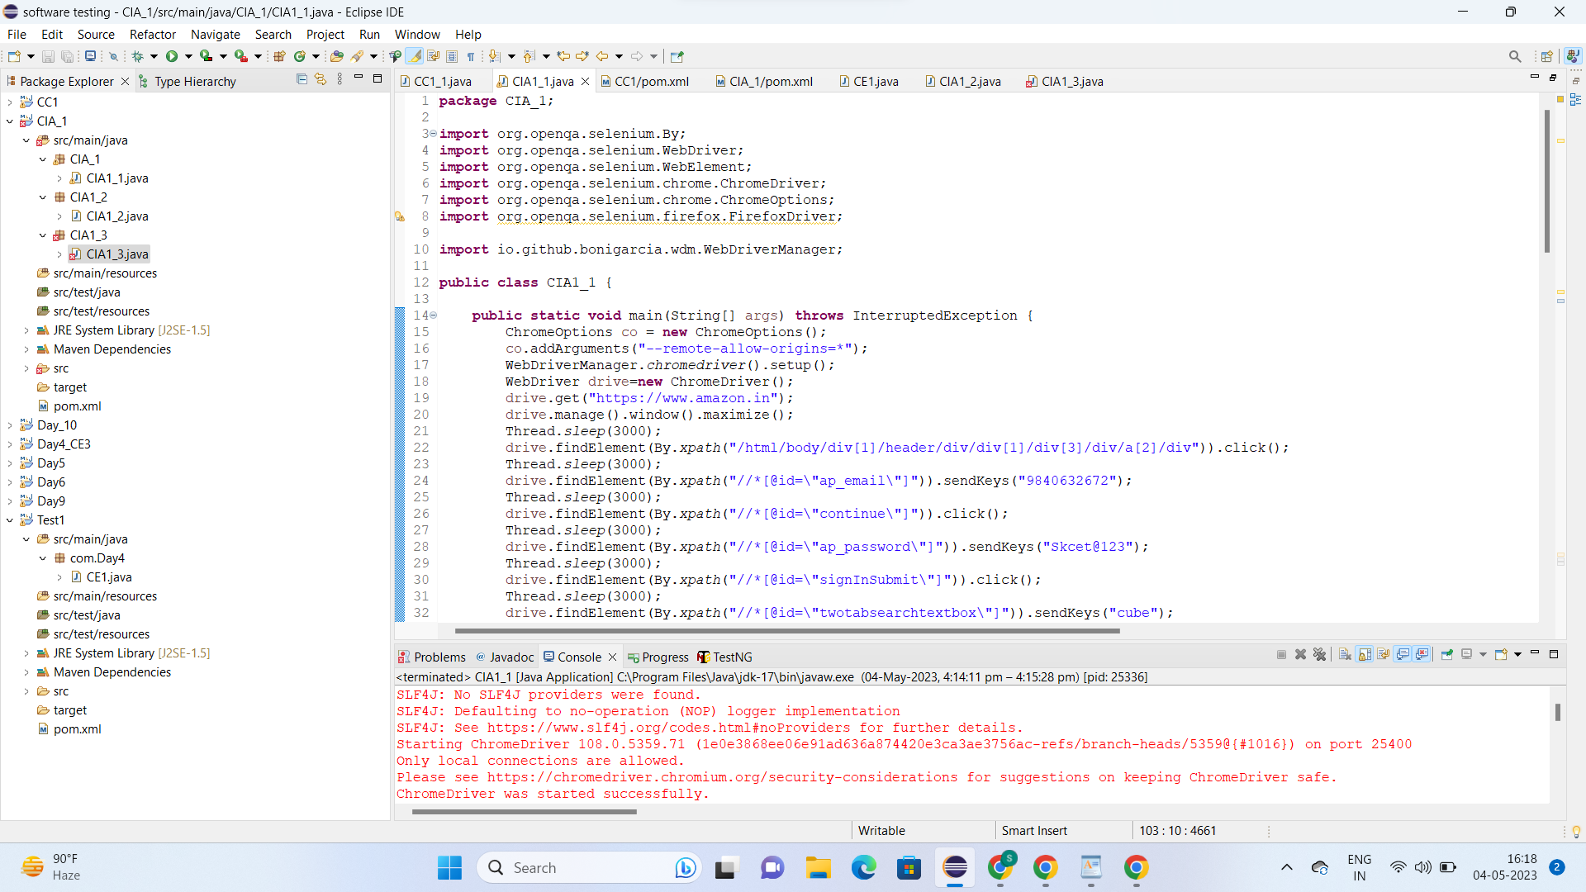

2)

CODE:

**package** CIA1_2;

**import** java.util.List;

**import** org.openqa.selenium.By;

**import** org.openqa.selenium.Keys;

**import** org.openqa.selenium.WebDriver;

**import** org.openqa.selenium.WebElement;

**import** org.openqa.selenium.chrome.ChromeDriver;

**import** org.openqa.selenium.chrome.ChromeOptions;

**import** io.github.bonigarcia.wdm.WebDriverManager;

**public** **class** CIA1_2 {

**public** **static** **void** main(String[] args) {

// **TODO** Auto-generated method stub

**int** productCount = 0;

ChromeOptions co=**new** ChromeOptions();

co.addArguments("--remote-allow-origins=*");

WebDriverManager.*chromedriver*().setup();

WebDriver driver=**new** ChromeDriver();

driver.get("https://www.amazon.in/");

driver.manage().window().maximize();

driver.findElement(By.*id*("twotabsearchtextbox")).sendKeys("oneplus");

driver.findElement(By.*id*("twotabsearchtextbox")).sendKeys(Keys.***ENTER***);

List<WebElement> tiltleElements = driver.findElements(By.*xpath*("//h2[@class='a-size-mini a-spacing-none a-color-base s-line-clamp-2']"));

**for** (WebElement titleElement : tiltleElements) {

System.***out***.println(titleElement.getText());

productCount++;

**if**(productCount == 5) {

**break**;

}

}

System.***out***.println("===========================================================");

WebElement sort = driver.findElement(By.*xpath*("//*[@id=\"a-autoid-0-announce\"]"));

sort.click();

System.***out***.println("Applied Filter!");

WebElement lhfilter = driver.findElement(By.*xpath*("//*[@id=\"s-result-sort-select_1\"]"));

lhfilter.click();

System.***out***.println("Applied Filter based on Price");

sort.click();

WebElement reviewfilter = driver.findElement(By.*xpath*("//*[@id=\"s-result-sort-select_3\"]"));

reviewfilter.click();

System.***out***.println("Applied Filter based on Reviews");

}

}

OUTPUT:

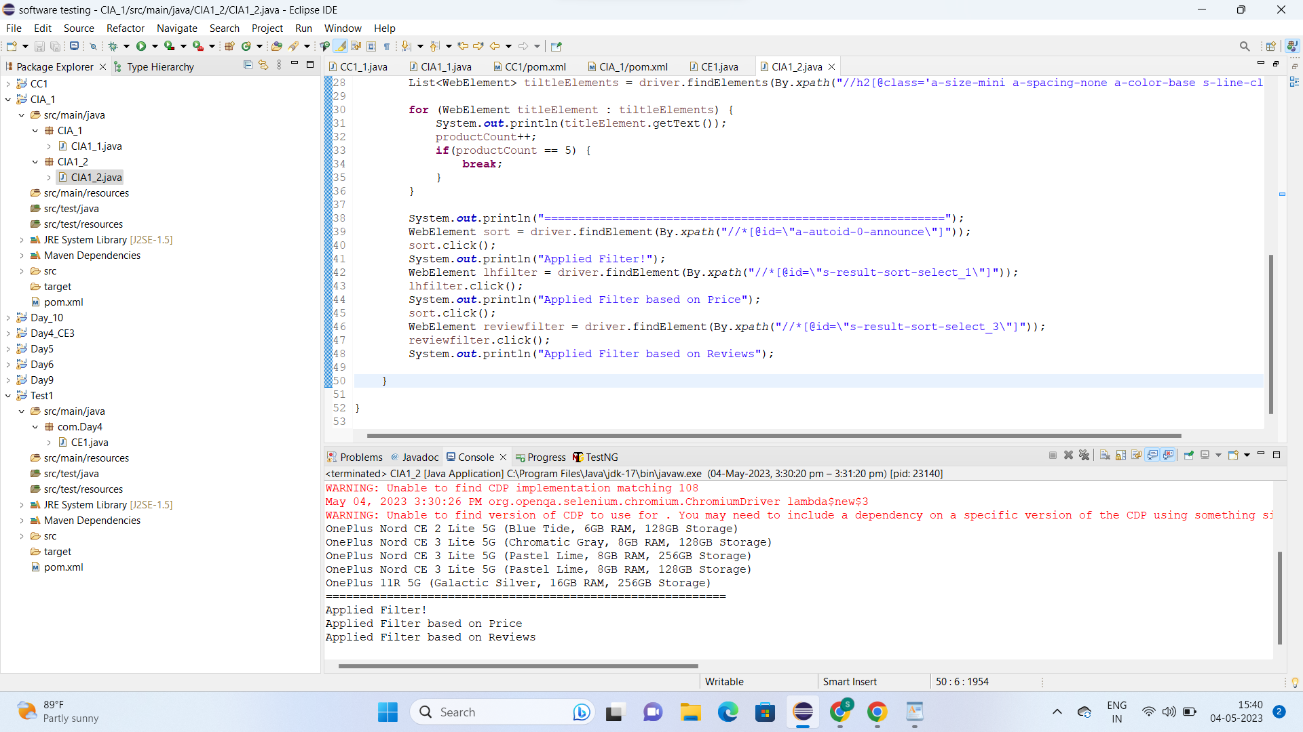

3)

CODE:

package com.testcase;

import java.util.List;

import org.openqa.selenium.By;

import org.openqa.selenium.Keys;

import org.openqa.selenium.WebDriver;

import org.openqa.selenium.WebElement;

import org.openqa.selenium.chrome.ChromeDriver; import org.openqa.selenium.chrome.ChromeOptions; import io.github.bonigarcia.wdm.WebDriverManager; public class App2 {

public static void main( String[] args )

{

ChromeOptions co=new ChromeOptions();

co.addArguments("--remote-allow-origins=*");

WebDriverManager.chromedriver().setup();

WebDriver driver=new ChromeDriver();

driver.get("https://www.amazon.in/ap/signin?openid.pape.max_auth_age=0& openid.return_to=https%3A%2F%2Fwww.amazon.in%2F%3Fref_%3Dnav_ya_s ignin&openid.identity=http%3A%2F%2Fspecs.openid.net%2Fauth%2F2.0%2Fi dentiﬁer_select&openid.assoc_handle=inﬂex&openid.mode=checkid_setup& openid.claimed_id=http%3A%2F%2Fspecs.openid.net%2Fauth%2F2.0%2Fide ntiﬁer_select&openid.ns=http%3A%2F%2Fspecs.openid.net%2Fauth%2F2.0&"

);

//sigin driver.ﬁndElement(By.xpath("//*[@id=\"ap_email\"]")).click();

driver.ﬁndElement(By.xpath("//*[@id=\"ap_email\"]")).sendKeys("6382023425")

;

driver.ﬁndElement(By.xpath("//*[@id=\"continue\"]")).click();

driver.ﬁndElement(By.xpath("//*[@id=\"ap_password\"]")).click();

driver.ﬁndElement(By.xpath("//*[@id=\"ap_password\"]")).sendKeys("deeksith 28");

driver.ﬁndElement(By.xpath("//[@id=\"signInSubmit\"]")).click(); driver.ﬁndElement(By.xpath("//[@id=\"nav-link-accountList\"]")).click();

WebElement

acc=driver.ﬁndElement(By.xpath("//*[@id=\"a-page\"]/div[2]/div/div[1]/h1")); String actual=acc.getText();

String expected="Your Account"; if(actual.equals(expected)) {

System.ouĒ.println("Your Account page is displayed");

}

driver.ﬁndElement(By.xpath("//*[@id=\"a-page\"]/div[2]/div/div[2]/div[1]/a/div")). click();

WebElement

ord=driver.ﬁndElement(By.xpath("//*[@id=\"a-page\"]/section/div[1]/div[2]/div[1

]/h1"));

String act=ord.getText(); String exp="Your Orders"; if(act.equals(exp)) {

System.ouĒ.println("Your Order page is displayed");

}

//

driver.ﬁndElement(By.xpath("//*[@id=\"a-page\"]/div[2]/div/div[2]/div[1]/a/div"))

.click();

// WebElement

trac=driver.ﬁndElement(By.xpath("//*[@id=\"a-page\"]/section/div[1]/div[2]/div[ 1]/h1"));

String act1=ord.getText(); String exp1="Your orders"; if(act.equals(exp)) {

System.ouĒ.println("User is able to track package");

}

// driver.ﬁndElement(By.xpath("//*[@id=\"pop\"]/div/div[2]/div/div[1]/div/div[3]/di v/div/div/div/div[2]/div/div/a")).click();

System.ouĒ.println("Cancel page displayed");

}

}

OUTPUT:

